Kyushu Institute of Technology

Logo.png

BIRDS-3 Satellite Project

Flight Model Thermal Vacuum Test Report

Laboratory of Spacecraft Environment Interaction Engineering



|  |  |  |  |
| --- | --- | --- | --- |
| **Date** | **Version Number** | **Writer** | **Annotations** |
| 2019/01/08 | v1 | Pooja | Initial Release |
| 2019/01/08 | v1.1 | Pooja | Added graphs |

**Table of Contents**

1. Introduction 3

**1.1** **Purpose** 3

**1.2** **Test date and place** 3

2. Test Facility 3

3. Test Schedule 4

4. Test article configuration 4

5. Position of Thermocouple (TC) 5

6. Test configuration for heater and satellites 7

7. Temperature tolerance for each component 8

8. Test Results 8

**8.1. Test output data** 8

**8.2. Temperature data from measurement point (TC)** 8

9. Summary and Conclusion 10

1. **Introduction**
   1. **Purpose**

This document contains the result of thermal vacuum testing for BIRDS-3 Flight Model (FM). The purpose of the test are as follows:

1. Verify the various satellite point temperatures under extreme hot and cold conditions.
2. Verify the functionality and operation of the satellite under the defined temperature range (extreme hot, extreme cold and middle temperature conditions).
3. Verify the operation of battery heater and thermal monitors under the defined temperature range.
   1. **Test date and place**

**Date:** 25th – 26th December, 2018

**Place:** Center for Nanosatellite Testing

Laboratory of Spacecraft Environment Interaction Engineering

Kyushu Institute of technology

1-1 Sensui, Tobata, Kitakyushu, 804-8550 Fukuoka, Japan

1. **Test Facility**

The list of equipment is shown below in Table 1:

|  |  |  |
| --- | --- | --- |
| **Equipment name** | **Model number** | **Quantity** |
| Thermocouple | Type-K | 6 |
| Thermocouple | Type-T | 36 |
| IR heater | 500x200 | 8 |
| Data acquisition PC |  | 1 |
| DAQ-mx | NI9213 | 3 |
| Power source | DC | 6 |
| Transceiver | IC-9100 | 1 |
| Functional Test PC |  | 1 |
| Controller | TNC-505 | 1 |
| Antenna | SRH8155 | 2 |

Table 1: List of equipment used during the test

1. **Test Schedule**

The test was carried out for 14 hours with detailed schedule as shown below in Figure 1:

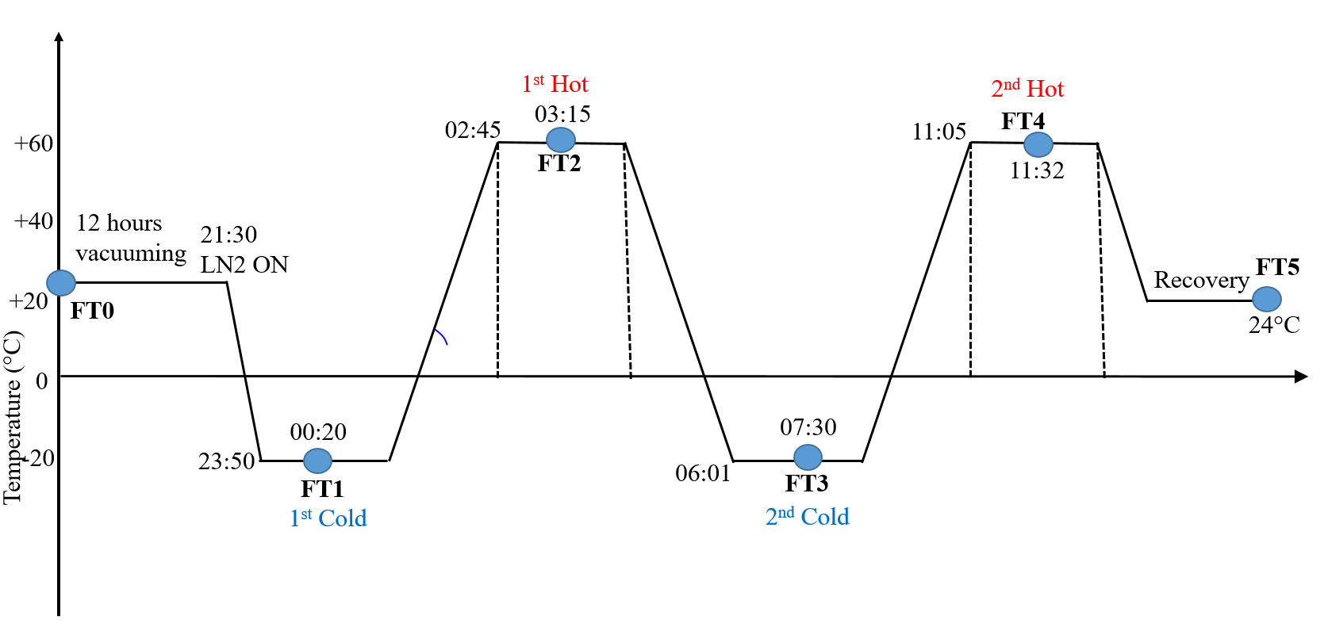

Figure 1: BIRDS-3 Flight model TVT profile

The entire TVT was carried out in two complete thermal cycles with targeted minimum and maximum temperature range from -25 oC to +60 oC respectively. A series of functionality tests (FT0-FT5) was carried out in order to assess the performance of the test article at each soak of the thermal cycles. When the battery temperature dropped below +8 oC, the internal battery heater was turned on to regulate the battery temperature.

1. **Test article configuration**

Thermal vacuum testing was conducted for Uguisu satellite in the small thermal vacuum chamber.

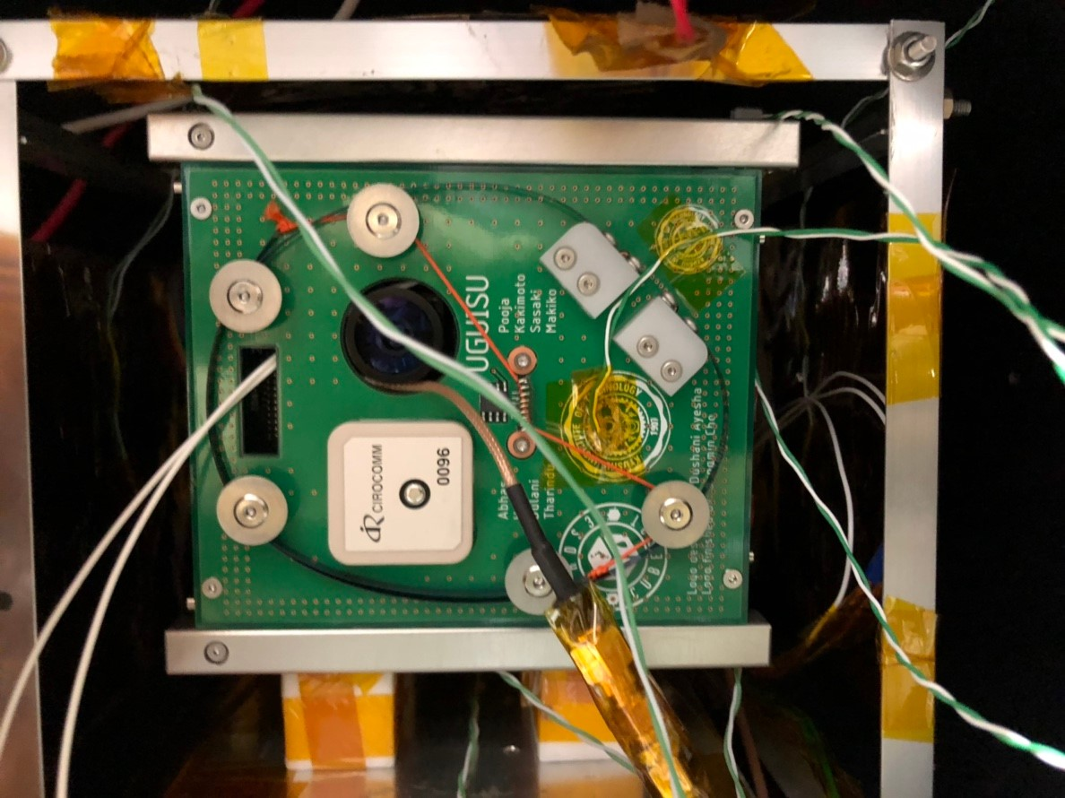

Figure 2: Set-up showing the Uguisu satellite for TVT

1. **Position of Thermocouple (TC)**

6 TCs were attached on each external panel of the satellite, 6 TCs were attached on the heaters facing each side of the external panel. See below in Table 2 and Figures 3-8.

|  |  |  |
| --- | --- | --- |
| **Sl.no.** | **Position** |  |
| 1 | +X Panel |  |
| 2 | -X Panel |  |
| 3 | +Y Panel |  |
| 4 | -Y Panel |  |
| 5 | +Z Panel |  |
| 6 | -Z Panel |  |
| 7 | -X Heater |  |
| 8 | +Y Heater |  |
| 9 | +Z Heater |  |
| 10 | -Z Heater |  |
| 11 | -Y Heater |  |
| 12 | +X Heater |  |

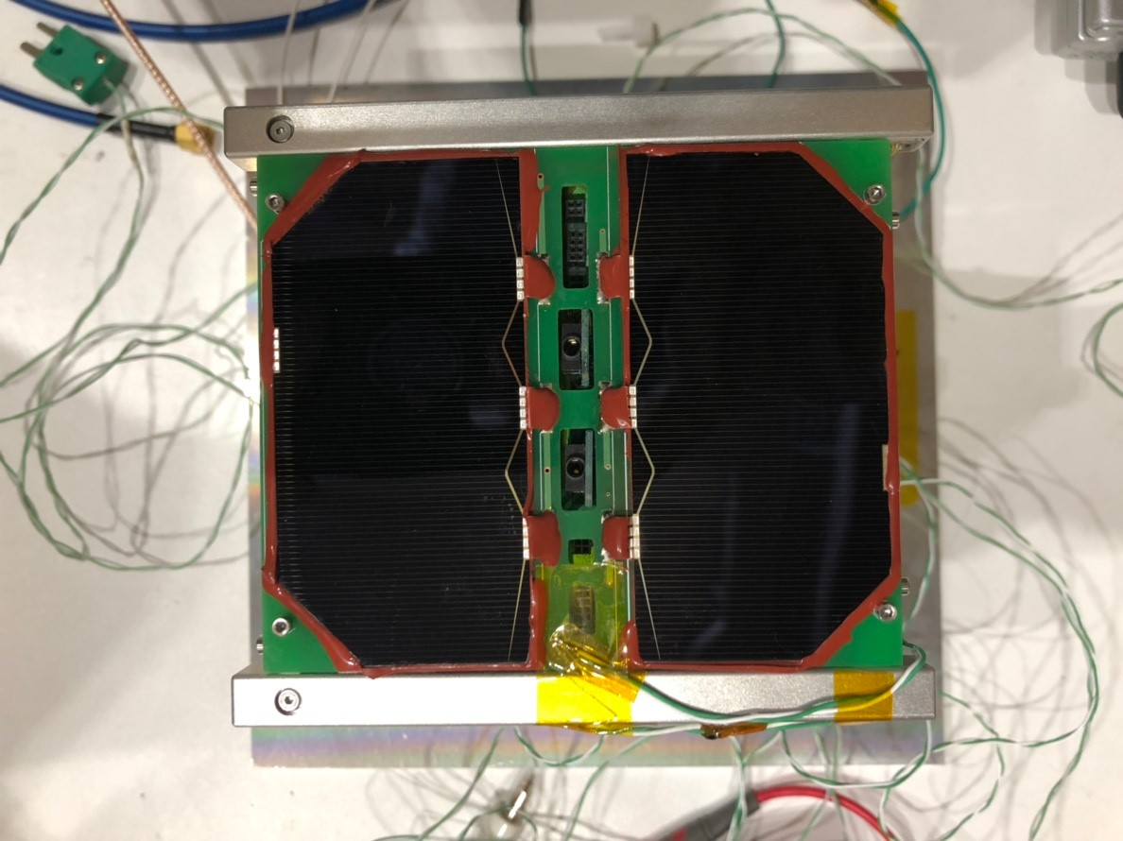Table 2: List of thermocouple placement

Figure 4: -X panel

Figure 3: +X panel

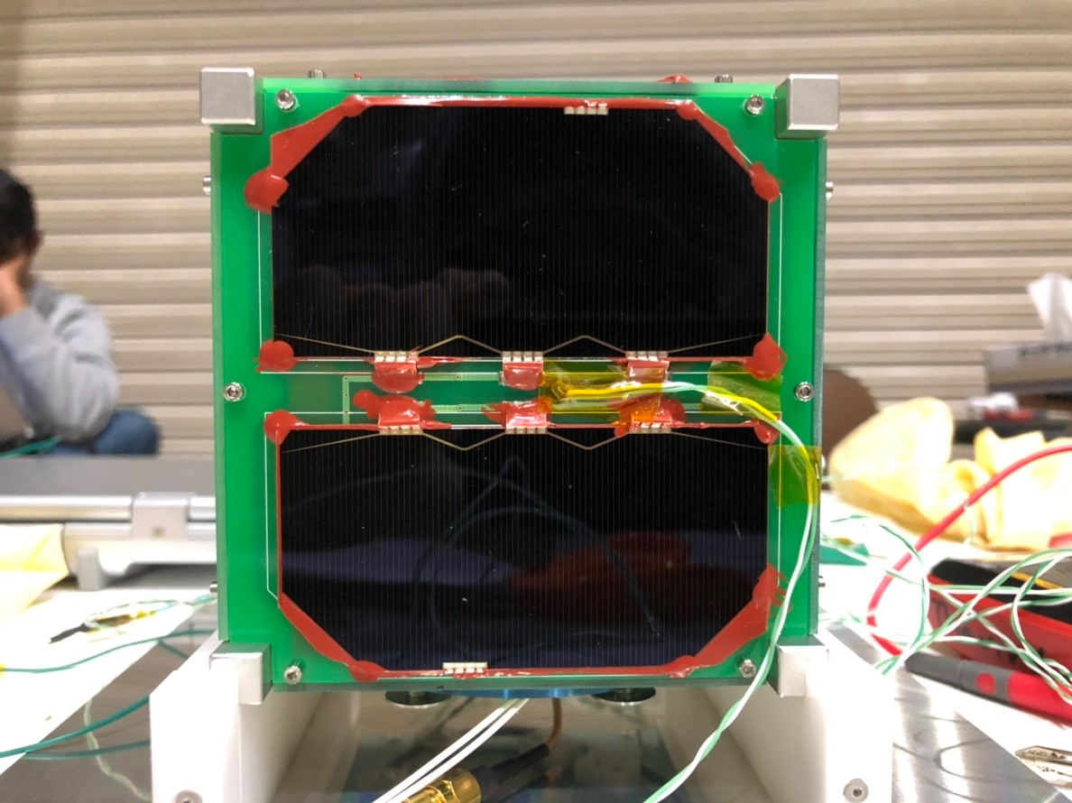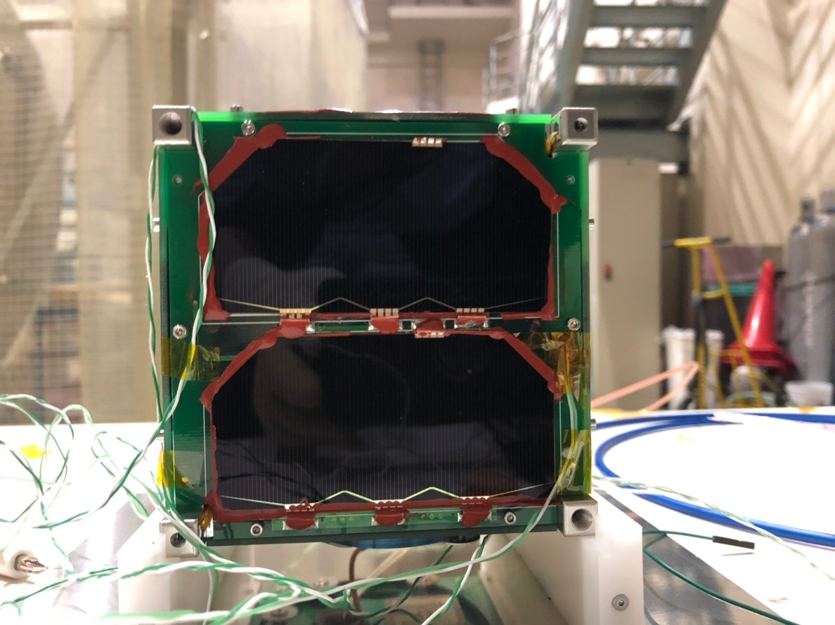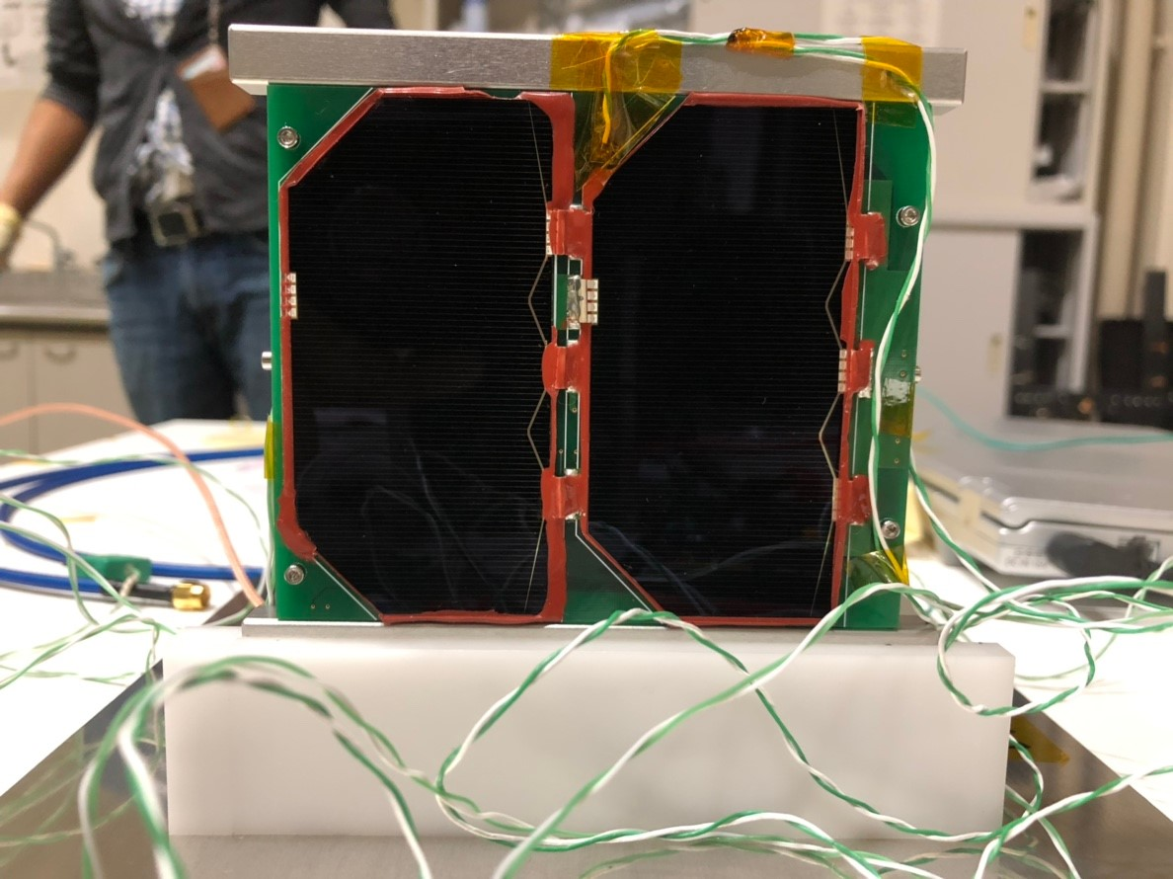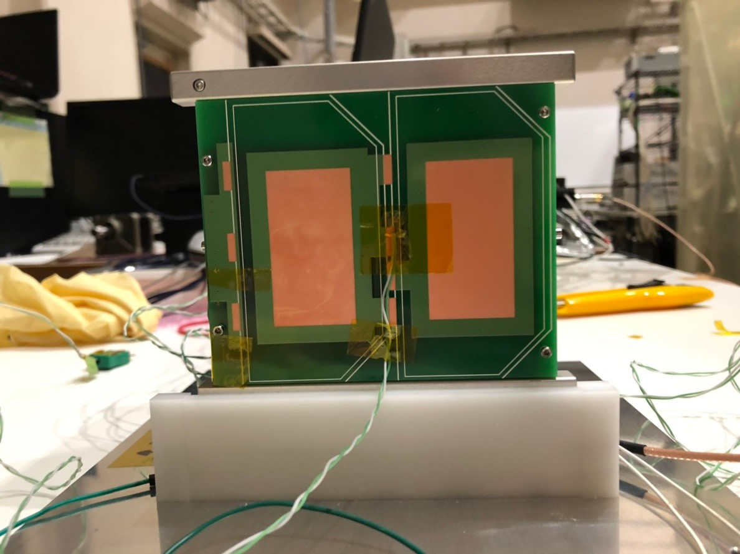

Figure 8: +Z panel

Figure 7: -Z panel

Figure 6: -Y panel

Figure 5: +Y panel

1. **Test configuration for heater and satellites**

|  |
| --- |
| Figure 9: Test configuration and setup |

The 3 satellites are placed in the center of the thermal vacuum chamber with a dummy at each end. Out of the two dummies, one is BIRDS-2 EM2. Heaters are placed in all four directions. Necessary equipment as shown in Figure 9 above are placed in order to perform the test.

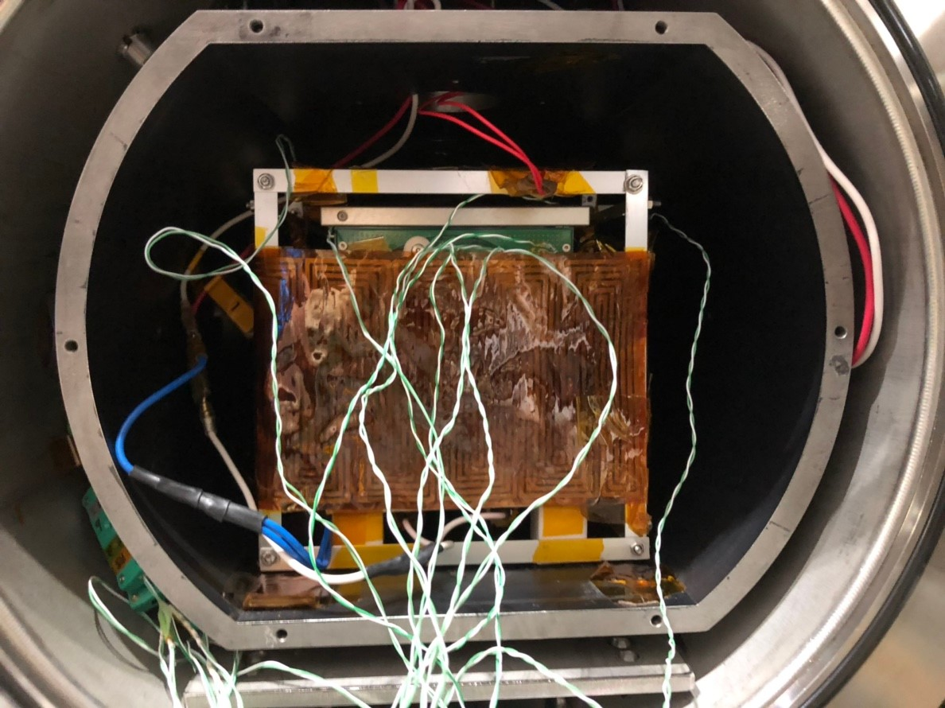

Figure 3: Thermal vacuum chamber and test article setup

1. **Temperature tolerance for each component**

Table 3 shows the temperature tolerance for each component of the satellites.

|  |  |  |
| --- | --- | --- |
| **Subsystem** | **Lowest (°C)** | **Highest (°C)** |
| FAB | -40°C | +80°C |
| OBC/EPS Board | -40°C | +85°C |
| Battery | 0°C | +40°C |
| COM-UHF TRX Board | -20°C | +60°C |
| LDM Board | -40°C | +85°C |
| Mission2 Board | -20°C | +70°C |
| RAB | -40°C | +80°C |
| -X Panel | -40°C | +85°C |
| CPLD Backplane | -40°C | +105°C |

Table 3: Temperature tolerance of each component

1. **Test Results**

**8.1. Test output data**

The thermal vacuum test data are temperatures of all measurement points from the beginning of test to the end of test. The total testing time is about 14 hours with 2 thermal cycles, the data output sample rate from LabVIEW program is 3 samples/minute. All of the values are stored as text data with timestamp output by LabVIEW program.

**8.2. Temperature data from measurement point (TC)**

Temperature profile data are shown in the figures below. The functional testing was conducted in each soak. The pressure in the chamber is less than 1×10-3 [Pa] during the entire testing period.

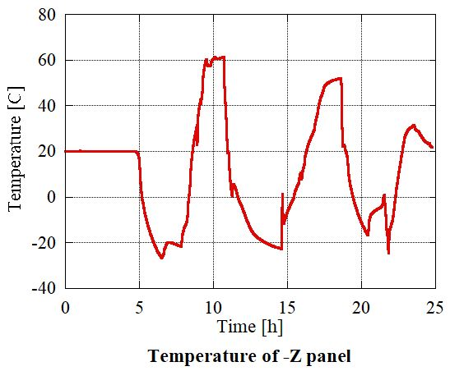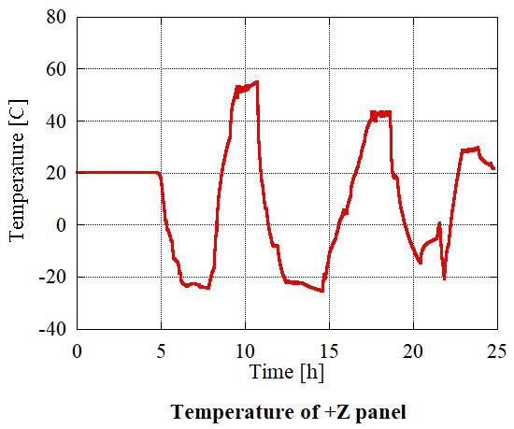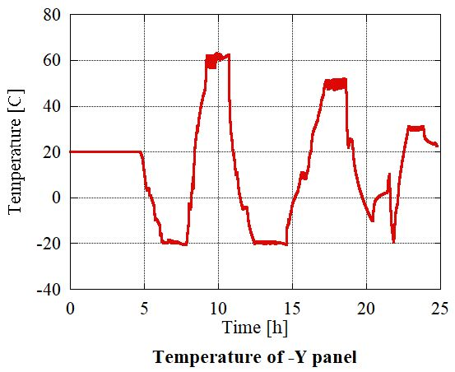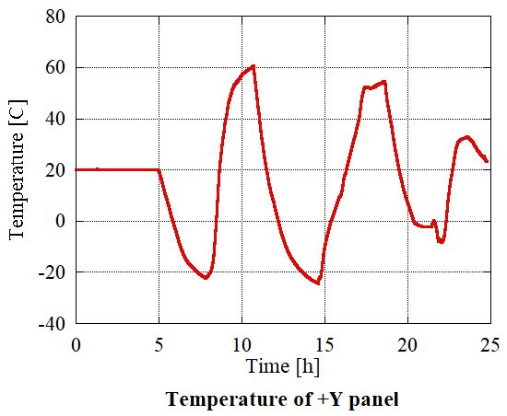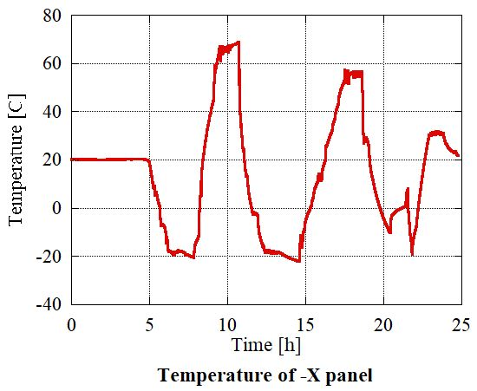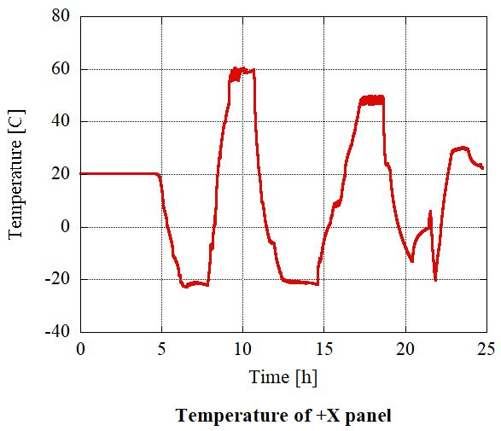

1. **Summary and Conclusion**

The thermal vacuum testing was conducted for Japanese flight model (Uguisu) of BIRDS-3 project. The temperature cycle range was -20°C to +60°C and the satellite was exposed to the vacuum environment. The flight model was functional in thermal vacuum environment.